20th Sunday in Ordinary Time August 19, 2012
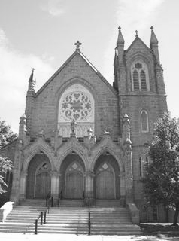
"Those who eat my flesh and drink my blood have eternal life, and I will raise them up on the last day; for my flesh is true food and my blood is true drink." (John 6:54:55)

WELCOME TO

THE PARISH UNIT OF

ST. BERNARD’S (Moncton)
SAINT VINCENT (Sackville)
SAINT CLEMENT (Port Elgin)
& SAINT BARTHOLOMEW (Melrose)

† MASS SCHEDULE †
St. Bernard’s: Thurs. @ 9:30 am; Sat. @ 4 pm & Sun. @ 11 am
St. Vincent: Sunday @ 9 am; St. Clement & St. Bartholomew: Sat. @ 7 pm (alternating)
Priest is available for Confessions prior to Saturday Mass upon request.

PASTORAL MINISTRY TEAM:
Priest Moderator: Rev. Allison S. Carroll Social Justice: Claudia McCloskey
Liturgy: Rick Shaw, Deb Gillespie Adult Faith: Dr. Andrew Wilson
Catechetics: Carolyn O’Blenis
STAFF:
Secretary: Darlene McGraw, sbhf@rogers.com Custodian: Rick Cormier
Facilities & Activities Coordinator: Sam Ermen
OFFICE: 43 Botsford St. Moncton, NB E1C 4W9 Phone 857-0425 Fax 857-9565
Web Site: www.stbernardschurch.ca

OFFICE HOURS: Mon. to Thurs. 9 am – 12 pm & 1 pm – 4 pm; Fri. 9 am – 12 pm

Mass Intentions for this Week

Thurs. Aug. 23rd@ 9:30 AM—late Bridget Walsh Charlie & Elsie Chamberlain

Sat. Aug. 25th @ 4:00 PM—anniv. late Anne Murray Mom & Dad

Sun. Aug. 26th @ 11:00 AM—late Doris Greenwood Boyd & Claire

OFFERINGS from last week—Aug. 11th & 12th, 2012
Envelopes (274)$ 5,624.50 Loose $ 731.65
Karing Kitchen $ 47.31 Capital Expenditure (37) $ 960.00
Thank you for your generous and continued support!
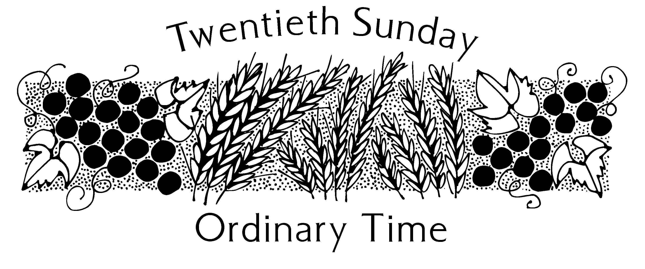

MARK YOUR CALENDARS
- 3rd Tuesday of Month @ 6:30 pm – Carmelites
- Last Sat. of every month @ 8:00 AM --Prayer for Priests in the main church
- Thurs. – after 9:30 AM Mass - Circle of Friends-done until September
- RCIA – Will start again on Wednesday, September 5th
- Baptisms – Next Scheduled Baptisms will be September 30, 2012

Prayers for our Troops…we pray for all those who serve………….we pray for Cpl. Ben Goodwin, son of Stephen & Ann Goodwin, Pvt. A.J. Poirier, son of John & Jackie Poirier, and Basil Rose, brother-in-law of Lew & Anne Cummings.

Ecclesiastes3…Under every season there is a time…
A TIME TO HEAL… We remember in our prayers those who are sick…... Billy Melanson, May Cox, Neil McDonald, Aurele Lavigne, Scott Yvonne, Bernard Cormier, Rita Leger, Bud Carroll.


A TIME TO MOURN………………our sincere sympathy to the family of...Eric Pineau, brother of Matilda Pineau.

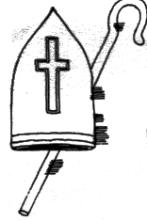
INSTALLATION OF NEW ARCHBISHOP – All members of the Archdiocese are invited to the installation ceremony of our new archbishop, Most Rev. Valéry Vienneau, at 7:00 PM on Wednesday, August 29th, at the Our Lady of the Assumption Cathedral. A reception will follow the ceremony in the basement of St. Bernard Church, on Botsford Street.

Parish Vitality Group will hold their second meeting on Sunday, August 26th @ 6:30 PM in the church hall.

Queen of All Saints Parish sponsors Scouting programs at Evergreen and St. Michaels, and have outdoor programs for Beavers (ages 5-7), Cubs ( ages 8-10), Scouts (11-14), Venturers (15-18). Outdoor programs start in September. Contact Garth Holder 388 3979, email gholder@nb.sympatico.ca, or search www/scouts.ca. for other Scouting opportunities.

All parishioners are cordially invited to a Day of Recollection, Sat., Sept. 15th, 9:00-3:30 @ St. Bernard's Parish basement. The theme being Verbum Domini, "The Word of the Lord." The guest speaker is Carmelite Friar Dominic Borg, OCD. Father Borg is a Scripture Scholar. Fee $ 10.00 for lunch. Pre-registration required by Sept. 1^{st.} Call Heather @ 384-0634 or Dorine @ 388-3699 or email: tjwhite@nbnet.nb.ca.
34131 Moberly Rd., Kelowna, BC V1W 3H9
34131 Moberly Rd., Kelowna, BC V1W 3H9

