Sixteenth Sunday in Ordinary Time July 22, 2012
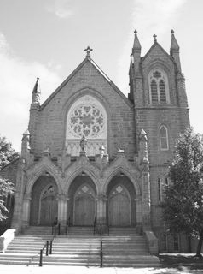
As Jesus went ashore, he saw a great crowd; and he had compassion for them, because they were like sheep without a shepherd; and he began to teach them many things. (Mark 6:34)

WELCOME TO

THE PARISH UNIT OF

ST. BERNARD’S (Moncton)
SAINT VINCENT (Sackville)
SAINT CLEMENT (Port Elgin)
& SAINT BARTHOLOMEW (Melrose)

† MASS SCHEDULE †
St. Bernard’s: Thurs. @ 9:30 am; Sat. @ 4 pm & Sun. @ 11 am
St. Vincent: Sunday @ 9 am; St. Clement & St. Bartholomew: Sat. @ 7 pm (alternating)
Priest is available for Confessions prior to Saturday Mass upon request.

PASTORAL MINISTRY TEAM:
Priest Moderator: Rev. Allison S. Carroll Social Justice: Claudia McCloskey
Liturgy: Rick Shaw, Deb Gillespie Adult Faith: Dr. Andrew Wilson
Catechetics: Carolyn O’Blenis
STAFF:
Secretary: Darlene McGraw, sbhf@rogers.com Custodian: Rick Cormier
Facilities & Activities Coordinator: Sam Ermen
OFFICE: 43 Botsford St. Moncton, NB E1C 4W9 Phone 857-0425 Fax 857-9565
Web Site: www.stbernardschurch.ca
OFFICE HOURS:
Please Note: Parish Office closed all next week from July 23rd to 27th.

Mass Intentions for this Week

Thurs. Jul 26th @ 9:30 AM—anniv. late Normand “Blackie” Cormier Shirley & family

Sat. Jul 28st @ 4:00 PM—late Verna Perry Sharon & Ross Burnett

Sun. Jul 29th @ 11:00 AM—late Ralph Fahey Family

OFFERINGS from last week—July 14th & 15th, 2012
Envelopes (251) $ 5,060.00 Loose $ 408.18
Karing Kitchen $ 12.65 Capital Expenditure (18) $ 1,535.00
Thank you for your generous and continued support!
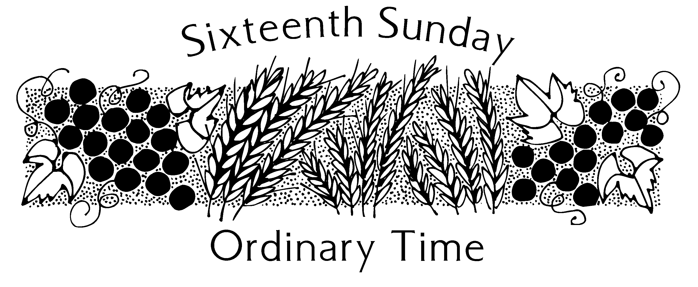

MARK YOUR CALENDARS
- 3rd Tuesday of Month @ 6:30 pm – Carmelites
- Last Sat. of every month @ 8:00 AM --Prayer for Priests in the main church
- Thurs. – after 9:30 AM Mass - Circle of Friends-done until September
- RCIA – Will start again on Wednesday, September 5th
- Baptisms – Next Scheduled Baptisms will be September 30, 2012


Prayers for our Troops…we pray for all those who serve………….we pray for Cpl. Ben Goodwin, son of Stephen & Ann Goodwin, Pvt. A.J. Poirier, son of John & Jackie Poirier, and Basil Rose, brother-in-law of Lew & Anne Cummings.


Ecclesiastes3…Under every season there is a time…
A TIME TO HEAL… We remember in our prayers those who are sick…... Cecile Fowler, Wendy O’Keefe, Peter deNiverville, Josephine Glidden, Tom Melanson, Joanne Colford, and Billy Melanson



A TIME TO MOURN………………our sincere sympathies to the families of…..Martha Pelletier, Thomas Connors, Helene Melanson & Frank Abbott



During the summer months the Parish office will close on Fridays at 12 noon until after Friday, August 31st.

IMPORTANT NOTICE – Parish Office will be closed all next week – from July 23rd to July 27th. The Parish Office will be re-locating to the Church basement in the Savage Room during that week. We will reopen in our new location on Monday, July 30th. Emergency messages can be left on the answering machine as this will be checked periodically.

There is a promise of Marriage between  Darcy Sears & Jennifer Yorston. Wedding to be celebrated on July 28th, 2012 at St. Bernard’s at 2 pm.

